**JavaScript from Beginner to Expert –Whole Practice Assignment**

**Problem:** Create the project and display the followings,

1. Using two-variable perform the following operations display the result in the console.

i. Arithmetic operations

ii. Relational operations

iii. Logical operations

2. Display the clock and date of day.

3. Take a string using the prompt box, display the string in the confirmation box if ok then shows in the alert box, this string is stored in cooking a maximum of 3 hours after hours it will expire.

4. Display the location of (URL) of the webpage.

5. Create an image gallery and add the Tooltip of each item.

6. Debug your project.

7. Using an online function dynamically change the background colour.

8. Take the array of some values, display the random values in the console.

**Solutions:**

Create the project and display the followings,

1. Using two variable perform the following operations display the result in the console.

i. Arithmetic operations

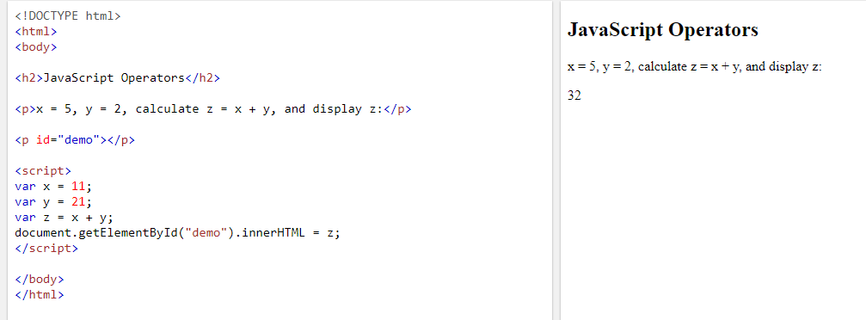

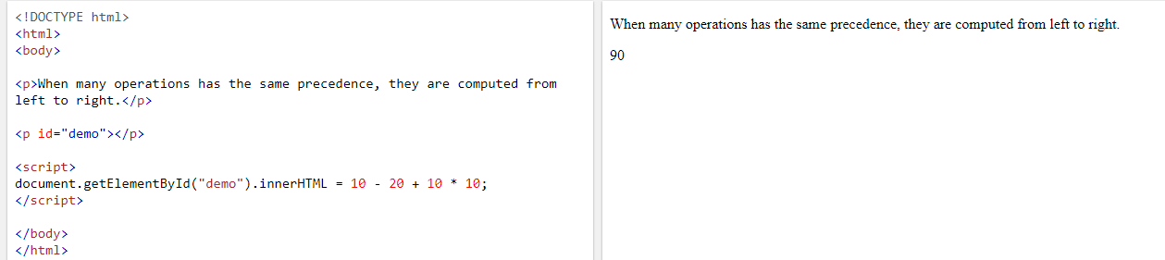

ii. Relational operations

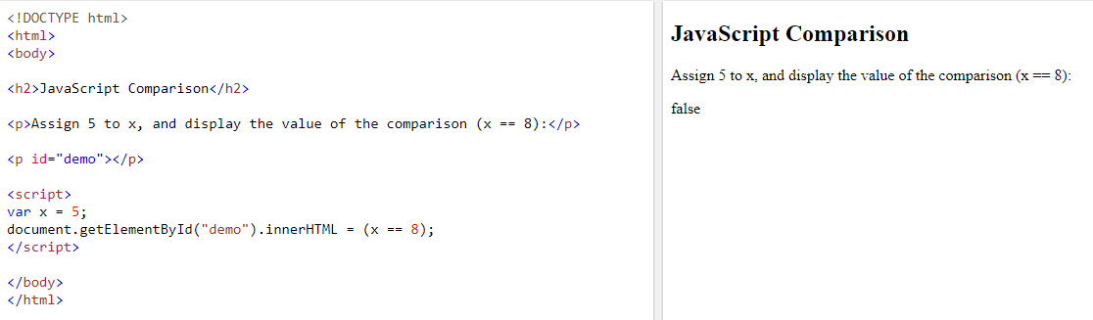

iii. Logical operations

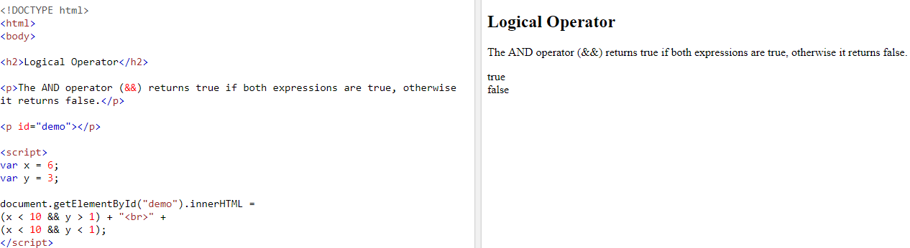

in Operator:

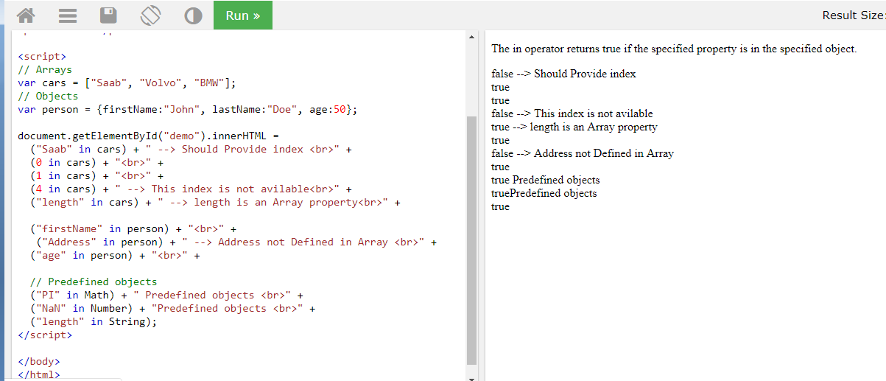

2. Display the clock and date of day.

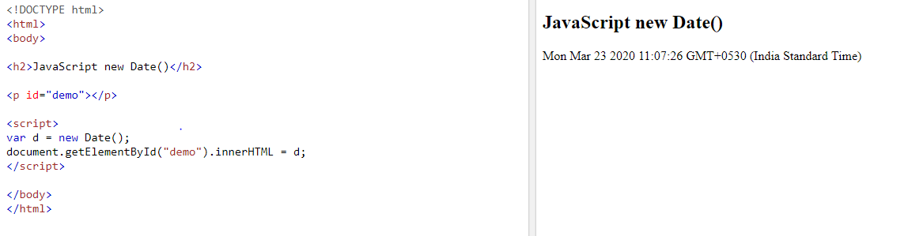

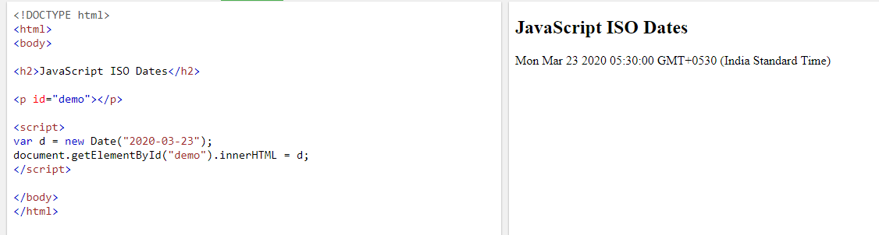

Date Parse:

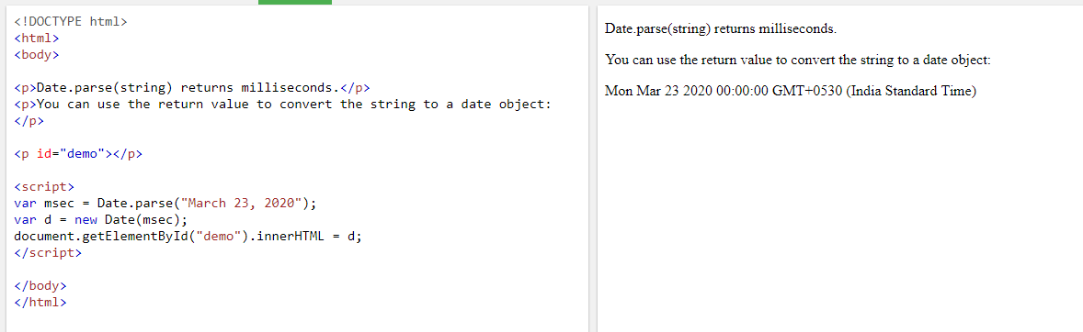

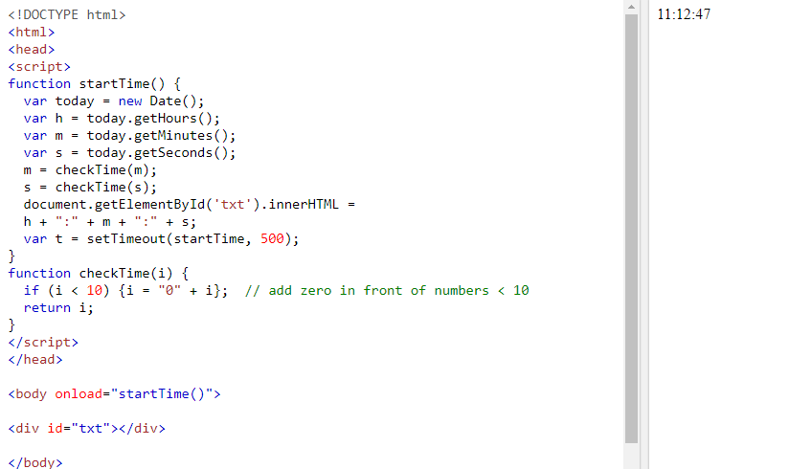

3. Take a string using the prompt box, display the string in the confirmation box if ok then shows in the alert box, this string is stored in cooking a maximum of 3 hours after hours it will expire.

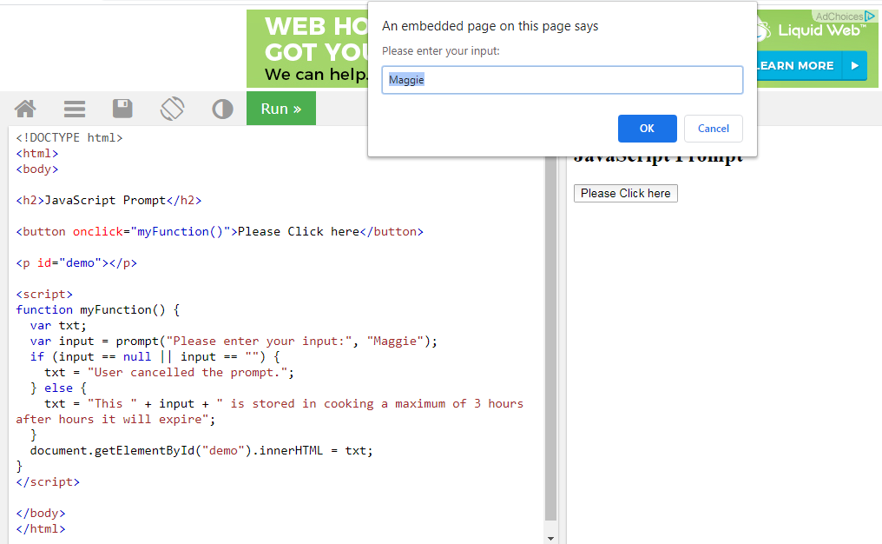

Confirmation Box:

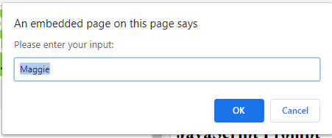

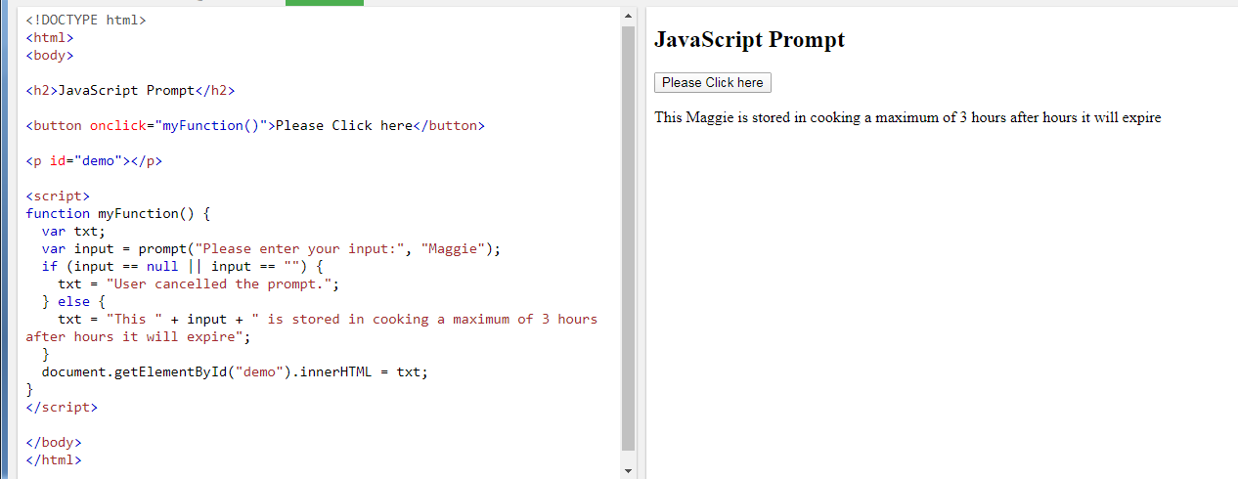

Alert:

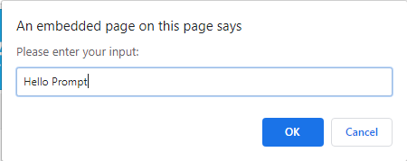

4. Display the location of (URL) of the webpage.

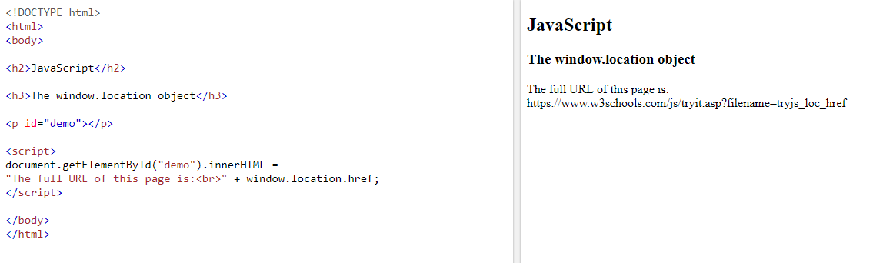

5. Create an image gallery and add the Tooltip of each item.

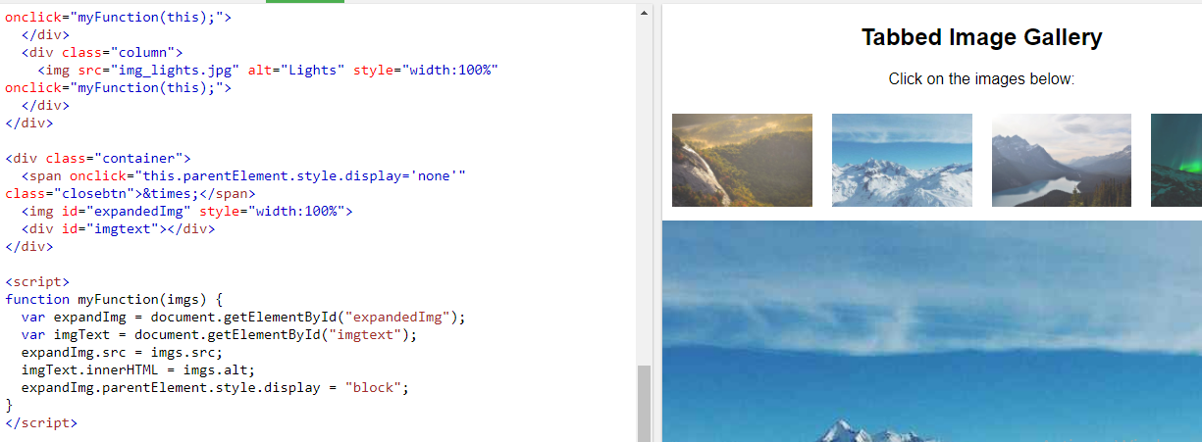

6. Debug your project.

Using debugger

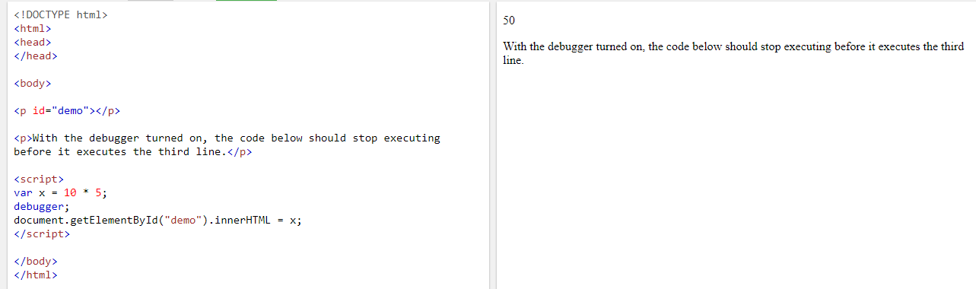

7. Using an online function dynamically change the background colour.

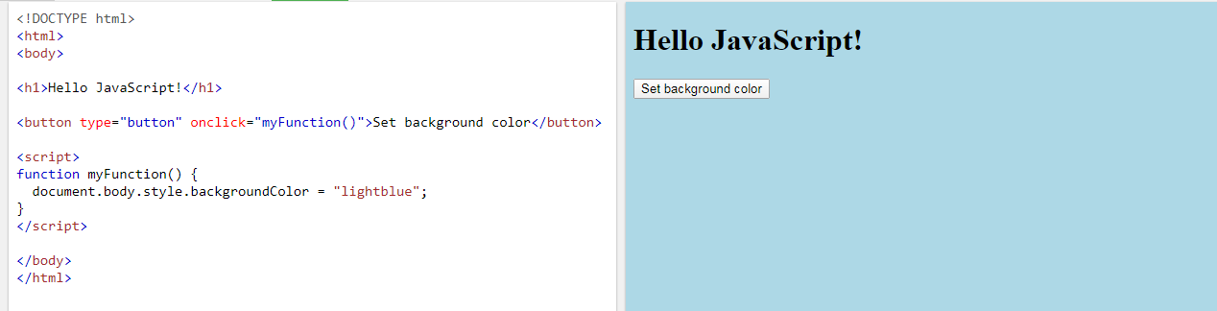

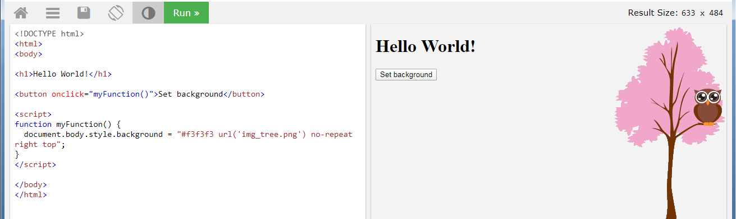

8. Take the array of some values, display the random values in the console.

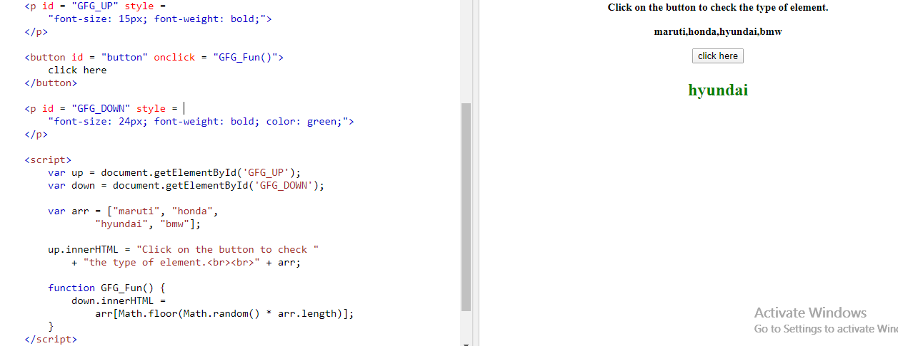

Array.forEach()

